**Name: Joel John Joseph**

**Roll No: 08**

**Batch: MCA-B**

**Date: 13/10/2022**

**DATA SCIENCE LAB**

**Experiment No.:**

**Aim**

Naïve bayes classification

**Procedure**

import pandas as pd

import numpy as np

from sklearn import preprocessing

data= pd.read_csv('golf-dataset.csv')

data

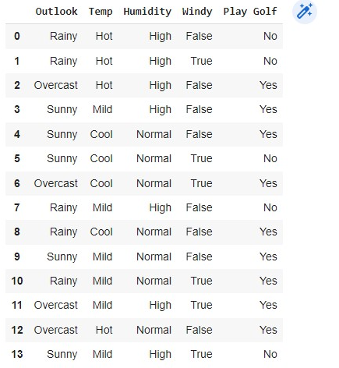

label_encoder = preprocessing.LabelEncoder()

data['Outlook']= label_encoder.fit_transform(data['Outlook'])

data['Temp']= label_encoder.fit_transform(data['Temp'])

data['Humidity']= label_encoder.fit_transform(data['Humidity'])

data['Windy']= label_encoder.fit_transform(data['Windy'])

data['Play Golf']= label_encoder.fit_transform(data['Play Golf'])

**Output**

